Step 1: Make sure you have all the needed files, they should be either on Github or the drive.

Step 2: Making the system environment variables. There are 4 variables needed to build : SDL1, SDL1_TTF, SDL1_MIXER, and SDL1_IMAGE

Open up System Properties and Click “Advanced system settings”

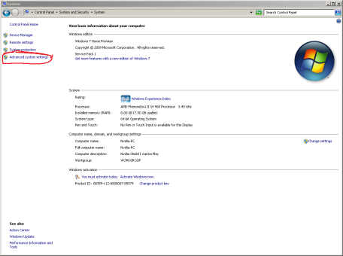

Click “Environment Variables”

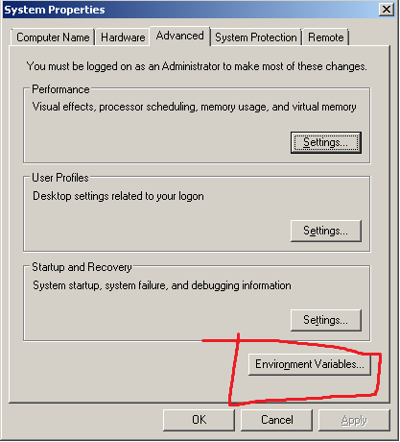

Select “New…”

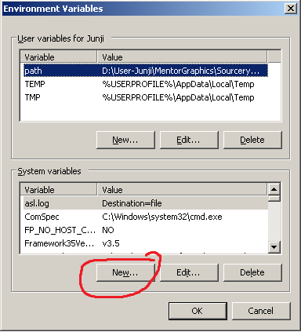

Add the variable name and location…

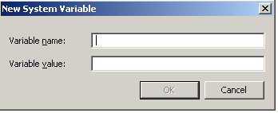

Repeat for all variables.

Step 3: Making sure VC10 variables are there.

Open up VC10 and click Project->rwars Properties

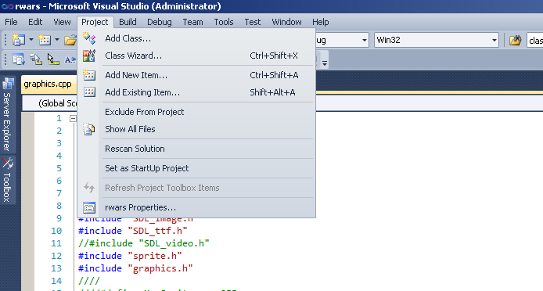

Go into VC++ Directories and edit the Include and Library Directories

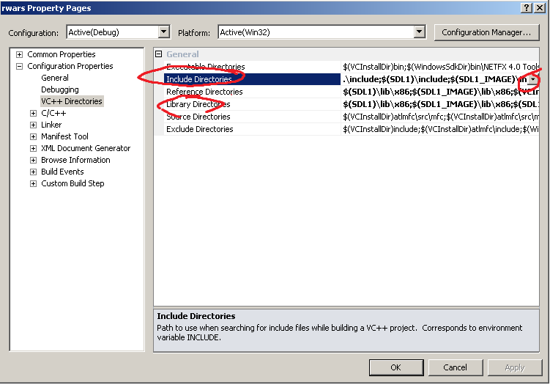

Add the includes using the following format

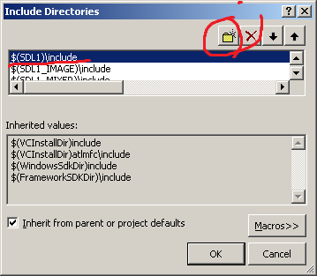

Add the libraries using the following format

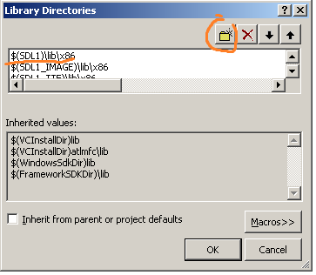

Go to Linker->Input and check if all the libs are there if not add them.

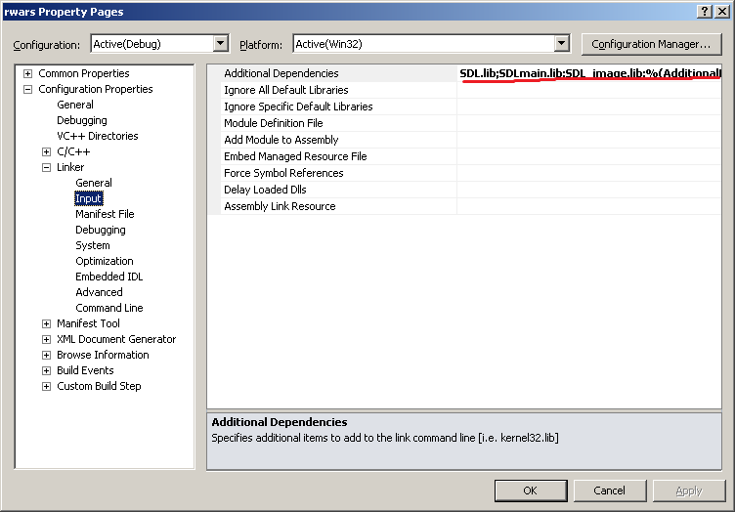

Step 4: Done voila!